Why is this particular parcel important relative to other land in the area? Is there other tribal ownership nearby, or is it because the land is available

The Malheur Mitigation Property resides 104 river kilometers downstream and the Logan Valley Mitigation Property is 64 river kilometers upstream. The proposed acquisition is located in Harney County. Most of the biologically critical habitat for native fish is present in the headwater tributaries, especially those tributaries in the upper Malheur River and North Fork Malheur River systems that originate in the Strawberry Mountains. Though Stinkingwater Creek is located in the upper Malheur River, its origin is southwest in the Stinkingwater Mountains. Though these mountain peak at lower elevation to the Strawberry Mountains, Stinkingwater Creek is noted of having good water resources. The upper reach of Stinkingwater Creek has historically provided spawning, summer rearing, winter rearing habitat for redband trout, and due to current management practices, the potential for productivity has decreased (NPCC 2004). The Malheur River Subbasin Assessment and Management Plan prioritize reaches for restoration based on the Qualitative Habitat Assessment performed on aquatic habitat in the Subbasin. Upper Stinkingwater Creek reach from the reservoir upstream to the headwater sources rank out as priority number 12 out of 57 for restoration. In addition, lower Stinkingwater Creek reach from the reservoir downstream to the Malheur River rank out as priority 15 out of 57 for restoration. Based on the Subbasin Plan, these reaches are of high priority restoration reaches for redband trout. The land is available for purchase.

In addition, an existing reservoir is on the current property. The reservoir is located at an elevation of approximately 3700 feet elevation (Figures 1 and 2). Similar reservoirs nearby have excellent trout fisheries providing angling opportunities. This Tribe viewed this as an attractive feature of the property. Instead of disturbing new grounds in developing a fishery, purchase an existing facility for an enhanced fishery for the Tribe. Investing in feasibility studies and construction costs for a similar sized project, purchasing an existing project may prove to be more cost efficient and will be able to acquire and protect native redband trout and terrestrial habitat resulting in a well rounded project with enormous benefits.

If a monitoring project has been going on somewhere in this watershed since 1997, what has been learned?

Current and past projects have been a cooperative effort between the Oregon Department of Fish and Wildlife, US Bureau of Reclamation, US Bureau of Land Management, US Fish and Wildlife Service, and US Forest Service. Data collection and design are discussed annually with these project cooperators. Project results and data are provided to the partners and any fishery management changes are implemented according to the direct authorities of the particular entity. It is evident the current projects have provided critical information for defensible land and fish management decisions and examples are provided as follows:

US Bureau of Reclamation – Results generated by the current project were imperative to the development of the US Fish and Wildlife Service Biological Opinion for Bureau of Reclamation Operations and Maintenance in the Snake River Basin Above Brownlee Reservoir (USFWS 2005). The Biological Opinion identifies detailed, non-discretionary actions in the Terms and Conditions that the Reclamation needs to adhere to. The terms of the Biological Opinion was developed from existing data, including those results from the current project.

The current project documented bull trout entrainment rate of 12% through the spill operations at Agency Valley Dam (Schwabe et al. 1999). This data was utilized to develop the condition 4.d in the Biological Opinion to continue existing efforts to trap and return bull trout that are entrained at Agency Valley Dam back to Beulah Reservoir or the North Fork Malheur River upstream of the dam. The Tribe has contracted directly with the US Bureau of Reclamation in 2005 and 2006 and has transported 0 and 7 adult bull trout respectively. With only 64 bull trout redds observed in the North Fork watershed in 2005, the transportation of these fish is critical for the local population.

The current project documented significant declines of fish populations in 2002, 2003 and 2004 compared to 1998 and 1999, including the number of bull trout utilizing the reservoir for winter rearing. Local fish managers were concerned that extreme low reservoir levels impact the population of the resident prey base in the reservoir. The identified decrease in fish numbers and the potential impact to the prey base of bull trout led to the development of term 4.a, 4.b, and 4.c in the USBR Biological Opinion that directs the Reclamation to research and identify minimum pool volumes for prey species, supplement prey source in years where drawdown levels are below a level sufficient to maintain habitat for bull trout prey, and identify and implement other mitigation strategies.

The current project has documented fluvial bull trout utilizing the mainstem Malheur River as winter rearing habitat from Logan Valley downstream to RK 175 through radio telemetry studies. A large diversion structure is located on the Malheur River at RK 259 and the head of Warm Springs Pool is located at RK 197. It is possible that fish forage as far downstream as Warm Springs Reservoir during winter, although bull trout have not been documented in Warm Springs Reservoir. Due to the lack of evidence of the presence of bull trout, changes in the operation of Warm Springs Dam to protect bull trout under the current Biological Opinion were not warranted. The US Fish and Wildlife Service Bull Trout Recovery Plan identify core recovery habitat on the Malheur River from the headwaters downstream to Namorf Dam (RK 107). The current project seeks to gain knowledge of native fish that lead to defensible fish management decisions which in this case was unable to change dam operations given the scientific data collected.

Oregon Department of Fish and Wildlife – Angling regulations were changed in the Malheur River above Warm Springs Reservoir and in the North Fork Malheur Reservoir to fly and artificial lure only after laboratory analysis suggested that two radio tagged bull trout that perished in the North Fork Malheur River was caused from angling.

Radio telemetry data suggested associated potential diversion loss with an unscreened diversion on the North Fork Malheur River above Beulah Reservoir. ODFW has approached the landowner and recently installed a fish screen to prevent any future diversion loss.

US Forest Service – Adult radio telemetry study was used to determine migratory movements and critical spawning areas in the both the upper North Fork Malheur River and upper Malheur River local populations. In 1999, cattle grazing regulations changed to conclude by August 15 on all bull trout critical spawning areas. In the North Fork system, allotment use shifted from cattle grazing to sheep grazing in Elk Creek, Sheep Creek and Swamp Creek to minimize the effect on rearing juvenile bull trout. In addition, undersized culverts were replaced on Forest Road 16 to improve migratory bull trout passage into critical spawning habitat on Little Crane Creek. In the upper Malheur, an undersized culvert was replaced in 2005 by a bridge to improve migratory bull trout into Meadow Fork Creek, a stronghold drainage for bull trout and critical spawning area for the local population.

Burns Paiute Tribe – The current project has been collecting data to identify actions that shall provide fisheries benefits to the ongoing wildlife projects, Logan Valley Wildlife Mitigation Site project no. 200000900, and Malheur River Wildlife Mitigation Site project no. 200002700. The current project has developed a monitoring protocol for fish habitat utilization on both properties. Monitoring protocols have been included in FY 2004 annual reports (Schwabe et al. 2005), and is on file in the department and available on the Bonneville Power Administration website. A habitat assessment has identified specific restoration activities at the Logan Valley site. In 2004, 3200 willow cuttings were planted on 1 km of lower Lake Creek and a bridge constructed replacing a ford crossing on Lake Creek through a grant from the US Fish and Wildlife Service Landowner Incentive Program.

How might these results support the proposed action? Where is the monitoring occurring relative to the subject property?

Monitoring efforts have been focused northeast of the proposed acquisition and near the Malheur River Mitigation Site below Warm Springs Dam. The current monitoring project has not collected information from this area but proposes a Subbasin wide genetic and population assessment that would include Stinkingwater Creek. Stinkingwater Creek enters the Malheur River at RK 236 below the Drewsey Irrigation Ditch that dewaters the Malheur River frequently. Upper Stinkingwater Creek above the reservoir is suspected to have the only available to sustain native redband trout populations as lower Stinkingwater Creek (below the reservoir) has very little value for redband trout spawning and incubation (NPCC 2004). This population is fairly isolated.

Does BLM have any work going on that would complement the Tribe's objectives: juniper control, range survey, etc? What about ODFW or neighboring land managers?

The proposed acquisition is located in a juniper encroachment area. The Tribe has received contract through the Bureau of Land Management to thin ponderosa and juniper stands in the local area. Harney County Watershed Council has funded numerous juniper control projects throughout the area.

It is unclear if redband live above or below the reservoir, but the presence of potential predators in the reservoir might be counterproductive to efforts to restore the redband. The reservoir has been stocked with trout and bass, is that what the future plan would be? It is the intent is stated to do restoration work but insufficient detail is presented to evaluate.

The reservoir may have the potential to be drained. If reservoir levels can be dropped to run of river for two years, it is suspected that eradication of crappie and largemouth bass is possible. Smallmouth bass will be troublesome but their presence is unknown.

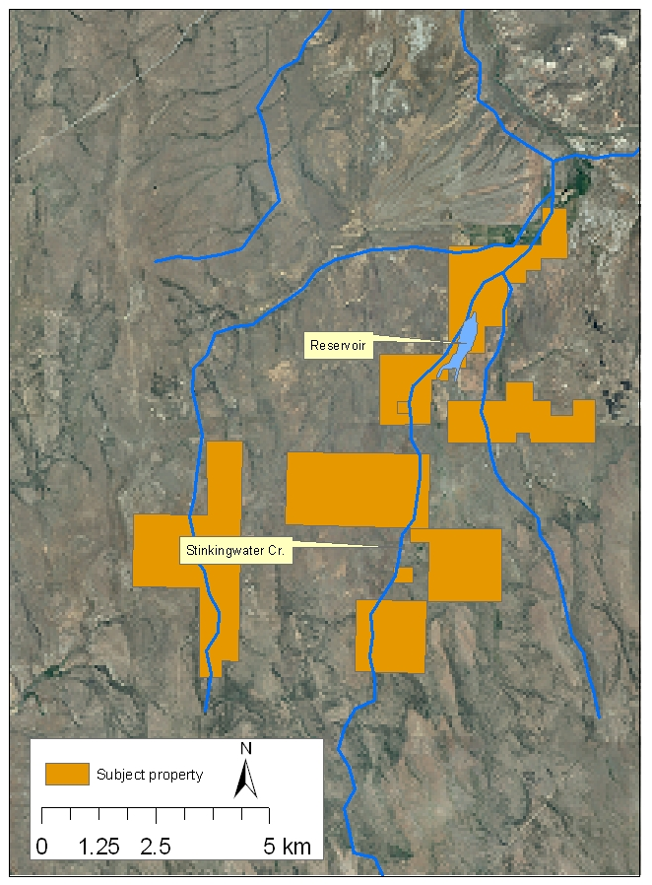

Figure 1.
Subject property on Stinkingwater Creek.

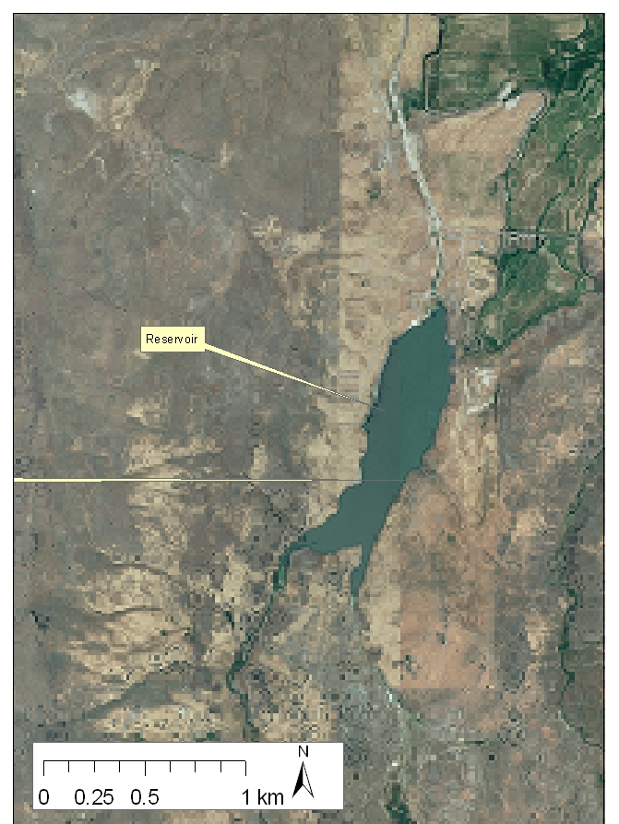

Figure 2.
Close up of the reservoir on the Subject property on Stinkingwater Creek.

General tasks are identified and put into sequence, but actual methods are not described or cited. Some goals mentioned earlier are not included in the objectives, such as increasing in-stream flow or improving grazing management. Perhaps this is not appropriate until baseline data and a management plan are in place, but it would be useful to outline the type of approach envisioned. Developing a monitoring plan is included, but not what will be monitored: habitat conditions, harvest, or compliance. Lack of results presented or reference to techniques from previous monitoring is worrisome.

Forecasted Biological Objectives and Work Elements for FY 2009

Biological Objective #5 – Improve riparian condition and channel conditions on approximately 15.1 km (9.4 miles) of stream.

Critical Assumption: We assume that adaptively applying restoration techniques including planting and grazing exclusion can restore normative function to riparian zones and increase their contribution to salmonids abundance and productivity.

Process Description: Project sponsor seek to restore all aspects of stream and riparian function. Total cattle exclusion is proposed above the reservoir. Below the reservoir prescribe riparian buffers to streams that will include: 1) Complete cattle exclusion from riparian buffers. Buffers shall be set either at 180 feet for each streamside (CREP maximum protection) or Rosgen (1998) 30-year flood inundation area, which ever is greatest. Proceed to plant native hardwoods in suitable areas throughout the 30 year floodplain. Stream and riparian function shall expand beyond limited riparian strip management and include the broad stream processes associated with interactive floodplain restoration.

Results Expected: We would expect to see an increase in hardwood density, habitat diversity, and riparian cover along the stream and within the floodplain. We expect to see an increase in habitat complexity due to increased hardwood densities in beaver dam complexes. We also expect to see increases in the water table or groundwater levels, increase pool habitat, increase shade and observe significant decreases in stream temperatures.

Effectiveness Monitoring: The project sponsor proposes to focus on economical based monitoring. Monitoring activities include photopoint for riparian densities, stream habitat assessments (ODFW 1998), and stream temperature monitoring Periodically conduct snorkel surveys on 20% of available stream habitat to determine on site salmonids habitat use utilizing the methods identified in BPA annual report (Schwabe et al. 2004). In addition, periodically sample population density monitoring sites proposed to be developed under project no. 199701900, Evaluation of the Life History of Native Salmonids in the Malheur River Basin, in Lake Creek, McCoy Creek and Crooked Creek to determine local population trend and response to restoration activities in Logan Valley.

Biological Objective #3 – Determine the feasibility of the development of an interim non-native put and take fishery with an optimum annual harvest of 680.4 kg (1,500 lbs).

Critical Assumption: We assume that the reservoir on Stinkingwater Creek has favorable conditions that shall support a put and take fishery for the Tribe.

Process Description: Project sponsor shall consult with local and private entities to determine the feasibility of developing a put and take fishery in the reservoir located on the proposed acquisition. Conduct baseline data assessment on the reservoir at determined monitoring sites. Determine what species of fish reside and if water quality is acceptable for a put and take fishery in the reservoir. Sample the reservoir twice a month from April to November for quantitative water quality measurements on dissolved oxygen, temperature, and turbidity. Two areas will be selected in the reservoir for monitoring: 1) at reservoir maximum depth and 2) on reservoir near inflow. Determine reservoir maximum depth by utilizing a boat and electronic depth sounder. Record GPS coordinates at several of the deepest locations and mark areas with buoys. Utilize an YSI model 57 to collect dissolved oxygen levels/water temperatures and a Van Dorn water sampler to collect unmodified water samples at depth. Conduct data and sample collections at depths 1, 5, 10, 20…., 30 meters. Analyze turbidity samples with a HACH 2100P turbidity meter and record in National Turbidity Units (NTU’s). The Tribal Council has not selected a particular fish stock, but staff highly suspects a triploid rainbow trout stock will be most successful. Triploid rainbow trout are put through a process that sterilizes the trout shortly after the eggs are fertilized, in turn reduces the potential of hybridization with native stocks of O. mykiss. ODFW has been greatly involved in the triploid rainbow stocking program in the local area due to fish stocking efforts in redband trout habitat in the Great Basin. The project sponsor shall build upon the successes the ODFW has with the Triploid program.

Results Expected: A completed feasibility assessment for the development of a put and take fishery in the existing reservoir utilizing triploid rainbow trout

Effectiveness Monitoring: The project sponsor proposes that economical based monitoring is needed to acknowledge that the best scientific principles are utilized by management to provide the Tribe with an effective and successful fishery. If deemed feasible, the project sponsor shall develop a detailed monitoring and evaluation component for the established fishery. Monitoring and evaluation activities should include water quality, creel, and fish growth/condition factor for stocked fish that shall aid management with identifying stocking rates and stock size. Many projects in the region use resident fish supplementation to substitute for the loss of salmonids. The sponsor proposes a review of ISRP recommendations of these projects and shall develop a detailed M and E for the established fishery.

Legal or realty expertise will be needed, but is not mentioned, nor is any terrestrial expertise noted for management of upland species or manipulation of rangelands. Information transfer plan is missing.

We anticipate all reality expertise will be provided under Biological Objective #1. The Tribe has legal services available for staff and this would be an appropriate Tribal concern to qualify for these services.

Biological Objective #1 – Acquire approximately 8,463 acres of land in the Stinkingwater Basin that will produce an optimum annual harvest of 2,563.6 kg (5,652 lbs) of fish and wildlife resources.

Work Element Name: Conduct Pre-Acquisition Activities
Work Element Description/Methodology: Coordinate with the land owner, BPA and the NPCC and complete all loss assessments and other requirements necessary to forward this project. Complete any required audits for the proposed acquisition. Complete and provide information to the title company for all necessary escrow transactions. The work element deliverable is a final realty package. The proposed closing for the acquisition of the proposed property should be complete in FY 2007.

References

Northwest Power Planning Council (NWPPC). 2004. Columbia River Basin Fish and Wildlife Program. NWPPC, Portland, OR.

Rosgen, D., and L. Silvey. 1998. Field Guide For Stream Classification. Wildland Hydrology Books. Pagosa Springs, Colorado.

Schwabe, L., S., J. Fenton, K. Fenn, and R. Perkins. 2004. 2003 Annual Report. “Evaluation of the Life history of Native Salmonids in the Malheur Subbasin: Project No. 1997-01900.

